30.34: a) 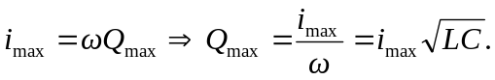
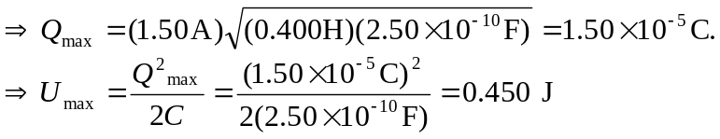
b) 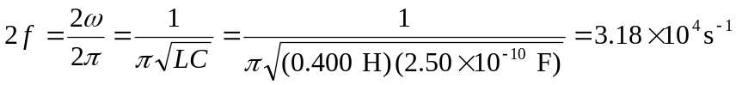
(must double the frequency since it takes the required value twice per period).

